

Alta California Elementary
& Gifted Magnet
Come join us for a parent workshop
With the Mental health advocates for
The Return to School and Covid

Date: Friday, April 23
Time: 2:30 p.m.
Zoom Meeting ID: 818 8304 400
Passcode: alta

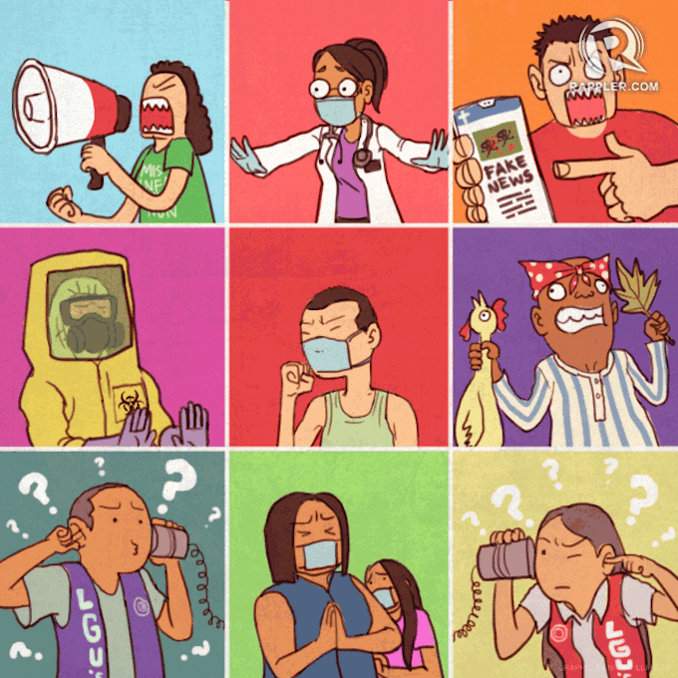


Acompañenos a un Taller para padres con

Los promotores de salud mental
“El Regreso a Clases y el Covid”

Fecha: viernes, 23 de abril, 2021
Hora: 2:30 p.m.
Zoom ID: 818 8304 400
Passcode: alta

